AITA

软件工程专业综合项目测试计划书

1652714 孙浩然

1652763 陈泽徽

1652751 梁钧清

1553545 王嵩豪

1652708 周泽林

1652698 康晓博

# 目录

AITA 1

目录 2

引言 3

背景与依据 3

选择模块 3

测试技术和过程 4

4.1 使用 ECP 技术对 auth 模块进行黑盒测试 4

4.2 使用 BVA 技术对 focus 模块进行黑盒测试 5

4.3 对usr 模块进行白盒测试 6

测试框架 15

# 引言

## 背景与依据

AITA 系统设计说明书

AITA需求分析

AITA 项目方案书

## 选择模块

本项目共选择三个模块进行测试，选择的三个模块分别为用户认证模块，专注度模块和用户信息模块。该三个模块的使用频率在本项目中最高，所以我们选择对这三个模块进行单元测试。

用户认证模块是系统中一个非常重要的模块，每一位使用本系统的用户都需要使用本模块进行用户认证。我们决定对用户认证模块采用黑盒测试的 ECP 测试方法。

专注度模块是本系统的核心功能，这个模块在系统主要负责管理用户的专注度数据，同时还对数据进行处理和分析。我们决定对这个模块采用黑盒测试的 BVA 测试方法。

用户信息模块是本系统中使用频率最高的一个模块，这个模块主要负责用户信息的管理，我们决定对这个模块采用白盒测试。

# 测试技术和过程

4.1 使用 ECP 技术对 auth 模块进行黑盒测试

以下是ECP技术的等价类及其代表：

|  |  |  |
| --- | --- | --- |
| 参数 | 等价类 | 代表 |
| username | vEC11: a certain sting inside database username storage | "init" |
|  | iEC11: null | "" |
|  | iEC12: a certain string but not in database username storage | "test" |
| password | vEC11: a certain sting matches password of username in database | "rightpwd" |
|  | iEC11: null | "" |
|  | iEC12: a certain string but does not match the password of username | "wrongpwd" |

以下是全部的测试情景：

|  |  |  |  |
| --- | --- | --- | --- |
|  | p参数 | |  |
| 测试情景 | username | password | 结果 |
| 1 | "init" | "rightpwd" | success login |
| 2 | "init" | "" | invalid input |
| 3 | "init" | "wrongpwd" | wrong password |
| 4 | "" | "rightpwd" | invalid input |
| 5 | "" | "" | invalid input |
| 6 | "" | "wrongpwd" | invalid input |
| 7 | "test" | "rightpwd" | wrong username |
| 8 | "test" | "" | invalid input |
| 9 | "test" | "wrongpwd" | wrong username |
| ... | ... | ... | ... |

4.2 使用 BVA 技术对 focus 模块进行黑盒测试

以下是测试类及其边界：

|  |  |
| --- | --- |
| 参数 | LBV, [EC], UBV |
| emotion | 0-δ, [0, _, 100], 100+δ |
| gaze | -20-δ, [-20, 20], 20+δ |
| rate | 0-δ, [0, 1], 1+δ |

以下是全部的测试情景：

|  |  |  |  |  |
| --- | --- | --- | --- | --- |
|  | 参数 | | |  |
| 测试情景 | emotion | gaze | rate | 结果 |
| 1 | 0 | -20 | 0 | success |
| 2 | 100 | 20 | 1 | success |
| 3 | -0.01 | -20.01 | -0.01 | invalid |
| 4 | 0.01 | -19.99 | 0.01 | success |
| 5 | 100.01 | 20.01 | 1.01 | invalid |
| 6 | 99.99 | 19.99 | 0.99 | success |
| 7 | 0.01 | 20.01 | 0.99 | invalid |
| 8 | 99.99 | -19.99 | 1.01 | invalid |
| ... | ... | ... | ... | ... |

4.3 对usr 模块进行白盒测试

我们队usr模块进行白盒测试，由于这个模块没有太多输入数据，我们没有很多测试情景。以下是测试的流程图：

**Get user info:**

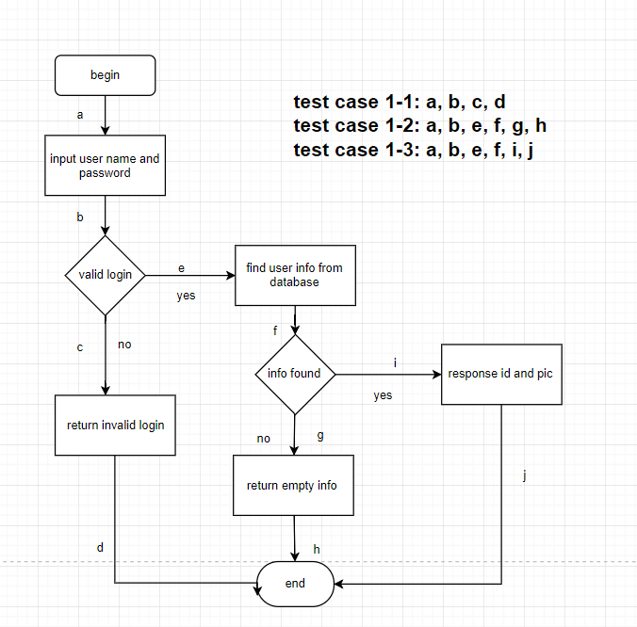

|  |  |
| --- | --- |
| NO. | Test case 1-1 |
| Functional module | User module |
| Case title | Test the input of invalid login |
| Prerequisite | Users input user name and password |
| Testing procedure |  |
| Expected results |  |
| Actually results |  |
| Remarks |  |

|  |  |
| --- | --- |
| NO. | Test case 1-2 |
| Functional module | User module |
| Case title | Test user information which is not found in database |
| Prerequisite | Users have logged in successfully |
| Testing procedure |  |
| Expected results |  |
| Actually results |  |
| Remarks |  |

|  |  |
| --- | --- |
| NO. | Test case 1-3 |
| Functional module | User module |
| Case title | Test the response id and pictures with valid login and found information |
| Prerequisite | Users have logged in successfully and user information can be found in database |
| Testing procedure |  |
| Expected results |  |
| Actually results |  |
| Remarks |  |

**Update user info:**

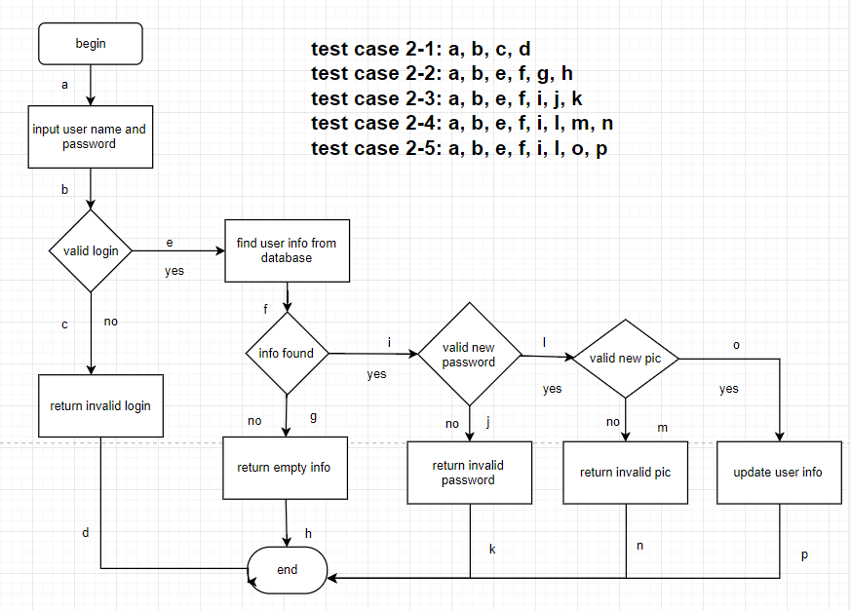

|  |  |
| --- | --- |
| NO. | Test case 2-1 |
| Functional module | User module |
| Case title | Test the input of invalid login |
| Prerequisite | Users input user name and password |
| Testing procedure |  |
| Expected results |  |
| Actually results |  |
| Remarks |  |

|  |  |
| --- | --- |
| NO. | Test case 2-2 |
| Functional module | User module |
| Case title | Test user information which is not found in database |
| Prerequisite | Users have logged in successfully |
| Testing procedure |  |
| Expected results |  |
| Actually results |  |
| Remarks |  |

|  |  |
| --- | --- |
| NO. | Test case 2-3 |
| Functional module | User module |
| Case title | Test the input of invalid password while updating user information |
| Prerequisite | Users have logged in successfully and user information can be found in database |
| Testing procedure |  |
| Expected results |  |
| Actually results |  |
| Remarks |  |

|  |  |
| --- | --- |
| NO. | Test case 2-4 |
| Functional module | User module |
| Case title | Test the input of invalid pictures while updating pictures |
| Prerequisite | Users have logged in successfully and user information can be found in database |
| Testing procedure |  |
| Expected results |  |
| Actually results |  |
| Remarks |  |

|  |  |
| --- | --- |
| NO. | Test case 2-5 |
| Functional module | User module |
| Case title | Test the successfull update of user information |
| Prerequisite | Users have logged in successfully and user information can be found in database, and users have input valid new password or pictures while updating |
| Testing procedure |  |
| Expected results |  |
| Actually results |  |
| Remarks |  |

**Update user password:**

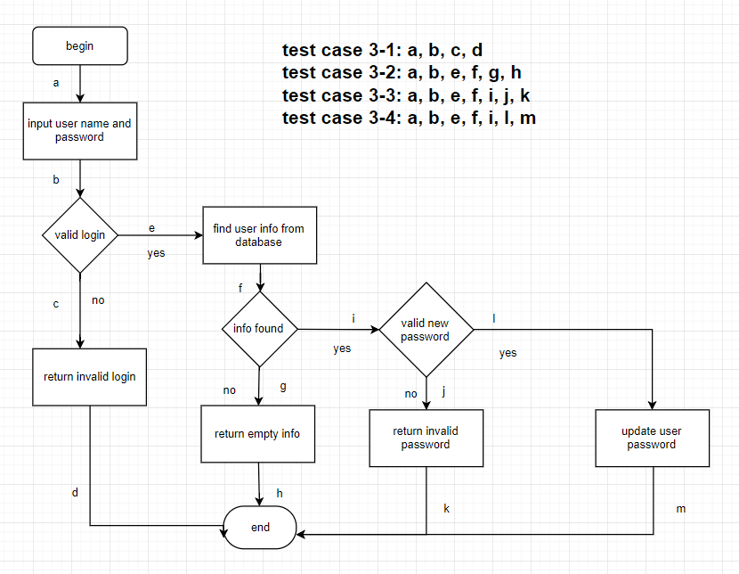

|  |  |
| --- | --- |
| NO. | Test case 3-1 |
| Functional module | User module |
| Case title | Test the input of invalid login |
| Prerequisite | Users input user name and password |
| Testing procedure |  |
| Expected results |  |
| Actually results |  |
| Remarks |  |

|  |  |
| --- | --- |
| NO. | Test case 3-2 |
| Functional module | User module |
| Case title | Test user information which is not found in database |
| Prerequisite | Users have logged in successfully |
| Testing procedure |  |
| Expected results |  |
| Actually results |  |
| Remarks |  |

|  |  |
| --- | --- |
| NO. | Test case 3-3 |
| Functional module | User module |
| Case title | Test the input of invalid password while updating user password |
| Prerequisite | Users have logged in successfully and user information can be found in database |
| Testing procedure |  |
| Expected results |  |
| Actually results |  |
| Remarks |  |

|  |  |
| --- | --- |
| NO. | Test case 3-4 |
| Functional module | User module |
| Case title | Test the input of valid password while updating user password |
| Prerequisite | Users have logged in successfully and user information can be found in database |
| Testing procedure |  |
| Expected results |  |
| Actually results |  |
| Remarks |  |

**Get user pic:**

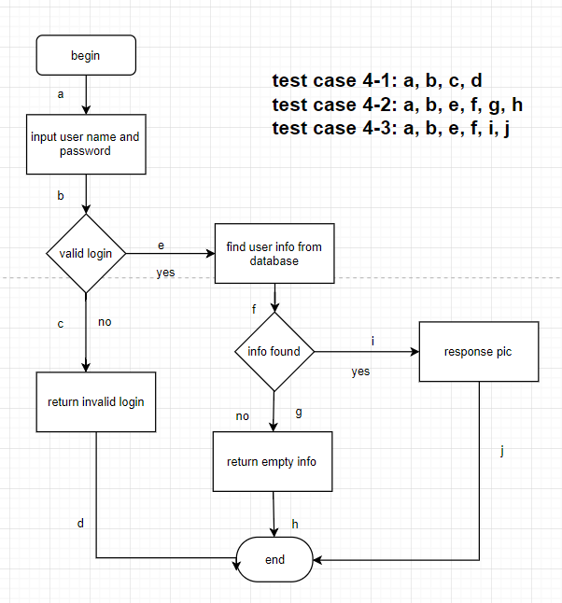

|  |  |
| --- | --- |
| NO. | Test case 4-1 |
| Functional module | User module |
| Case title | Test the input of invalid login |
| Prerequisite | Users input user name and password |
| Testing procedure |  |
| Expected results |  |
| Actually results |  |
| Remarks |  |

|  |  |
| --- | --- |
| NO. | Test case 4-2 |
| Functional module | User module |
| Case title | Test user information which is not found in database |
| Prerequisite | Users have logged in successfully |
| Testing procedure |  |
| Expected results |  |
| Actually results |  |
| Remarks |  |

|  |  |
| --- | --- |
| NO. | Test case 4-3 |
| Functional module | User module |
| Case title | Test the response pictures with valid login and found information |
| Prerequisite | Users have logged in successfully and user information can be found in database |
| Testing procedure |  |
| Expected results |  |
| Actually results |  |
| Remarks |  |

测试框架

在本系统的测试过程中，我们将选用 pytest 作为我们的测试框架。Pytest 测试框架让我们可以更加轻松地写简单的单元测试，同时对大型复杂的项目测试也提供支持。由于我们软件项目的后端采用Python语言的flask框架书写，pytest成为我们测试的不二选择。